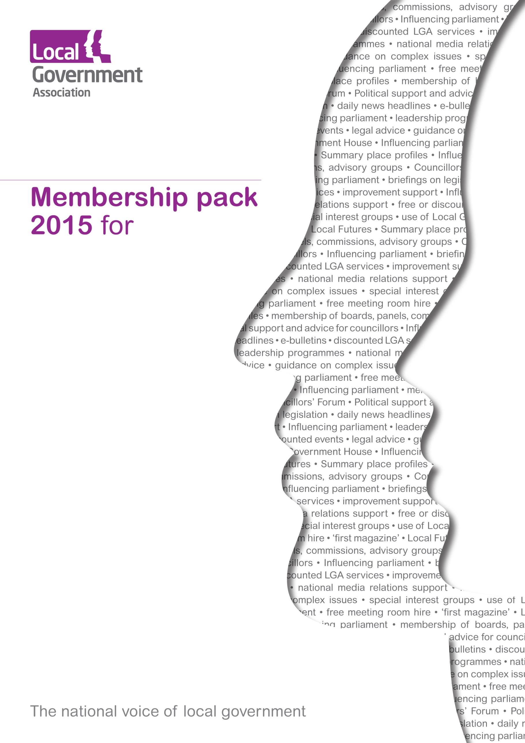

Council Name

**Welcome to the Local Government Association 2015/16**

2015 will be an incredibly important year for local government. The General Election will determine who governs the country until the end of the decade and whatever the outcome, we know that councils will continue to face significant challenges.

You have told us about the issues that matter to you and to your residents and that’s why in the next year we will focus our efforts on influencing the next government. Finance and devolution of powers are central to our lobbying and influencing work. The outcome of the next Spending Review will be crucial to ensuring you have the funding to provide vital services.

Our campaign, ‘Investing in our nation’s future: 100 days of the next Government’, has put local government at the centre of the manifesto debates, setting out a costed plan to tackle key issues such as growth, housing, jobs and skills, schools, social care, the nation’s health and our roads – All issues that matter to our residents.

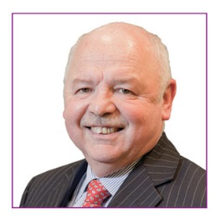

We will continue to provide a strong voice for councils – standing up for local government and ensuring people hear the great story local government has to tell. We know your budgets are under tremendous pressure, but I hope this report demonstrates that your LGA membership is helping to save you money and ensuring that local government has the future our residents deserve.

**Cllr David Sparks, Chair**

|  |  |  |  |
| --- | --- | --- | --- |
| The LGA’s political leadership is committed to offering the best value for money to our member councils. **Over the past five years, we have reduced our total subscription income by 30 per cent. This year, alongside the 2.5 per cent early payment discount for payment by 1 June, we are once again offering an additional 2.5 per cent loyalty discount for councils not on notice to withdraw from LGA membership.**  «MERGE Local_Authority»’s subscription for 2015/16 is «Subscription_2015/16_» – a reduction of «Reduction_in_Subscriptions_since_2009» per cent since 2009. | | | |
|  | | | |
| img3 | **Cllr Gary Porter**  **Vice Chairman**  **Leader, Conservative Group** | img4 | **Cllr Gerald Vernon-Jackson**  **Vice Chair**  **Leader, Liberal Democrat Group** |
|  | **Cllr Jim McMahon**  **Vice Chair**  **Leader, Labour Group** | img6 | **Cllr Marianne Overton**  **Vice Chair**  **Leader, Independent Group** |
| C:\Users\Claire.Holloway\AppData\Local\Microsoft\Windows\Temporary Internet Files\Content.Outlook\2T3GDP1M\106-1800710132-O.jpg | **Carolyn Downs**  **Chief Executive** |  |  |

|  |
| --- |
| This section will be broken down to give specific benefits to the councils and wider benefits to local government and local areas |

**What the LGA has done for «Local_Authority» in 2014**

In 2014, working closely with councils, we secured some substantial ‘wins’ and additional funding on your behalf, including:

* Specialist legal support at a fraction of the cost to individual councils against claims for repayment of local land searches. The settlements for each council are in the process of being finalised but overall, we have saved councils **£329 million (Can be broken down)**. Government has also agreed to reconsider our application for additional funding for councils to cover some of the costs they have incurred
* The recovery of more than 95 per cent of the money councils deposited with the failed Icelandic Bank, Landsbanki, bringing the total sum retrieved to more than **£1 billion**

*“I don't think they are going to get much money back - unless the government bails them out, which they should not do of course. I would not bet on any recovery.”*

Willem Buiter, former member of the Bank of England’s Monetary Policy Committee speaking on councils’ prospects of recovery

Channel 4 News, February 2009,

* a landfill tax freeze for 2015/16, **saving councils nearly** **£60 million**
* a **£168 million** ‘pothole fund’(**Can be broken down**) for councils
* an additional **£270 million** for flood defences over the next three years, **£184 million** for road repairs and **£135 million** for recovery schemes (**Year 1 Can be broken down**)
* helped establish the **£5.3 billion** Better Care Fund, contributing at least **£2.4 billion** directly to social care services **(Can be broken down - TBC**)
* an **£11 million grant for** **social care in prisons**, relieving the strain on the Better Care Fund for councils with prisons within their boundaries (**Can be broken down**)
* an extra **£4 million** for the regions and **£19 million** **for individual councils** to support local implementation of the Care Act (**Can be broken down**)
* a **new Carers and Care Act Implementation grant** for 2015/16 (**Can be broken down**)
* ensuring that the new burdens grant for localised Council Tax Support willcontinue to be paid in 2015/16 (**Can be broken down**)
* additional schools capital funding of **£2.35 billion** for 2015-2017 and an extra **£390 million** for the 66 worst-funded councils (**Can be broken down**)
* an additional **£300 million** in borrowing for the Housing Revenue Account. 15 councils have already been awarded £60 million from this initiative (**Can be broken down**)
* **£2 million** additional funding to support commissioning arrangements in 2015/16 for public health services for 0-5 year olds (**Can be broken down**)
* **£2.5 million** **for Local Support Services** for Universal Credit
* a **£16 million** **challenge fund** available for counter fraud initiatives
* **£330 million** of further education capital spending to Local Enterprise Partnerships

We also lobbied to prevent further reductions in council funding, including:

* **Limiting a proposed reduction** to the £315 million Housing Benefit Administration subsidy for 2015/16 to a 10 per cent efficiency saving and a reduction to reflect the transfer of responsibility for benefit fraud
* **stopping** a government proposal to force councils to run local post-16 application schemes, costing each council up to £340,000 a year.
* Secured agreement that councils will keep **100 per cent of business rates from fracking**
* set up a Municipal Bonds Agency to **offer councils cheaper capital borrowing** than the Public Works Loans Board certainty rate
* established an auditing body which will **save councils £100 million** over the next two years in fees paid to external auditors
* successfully lobbied the Department for Local Government and Communities to look at innovative ways of improving statutory notices, with councils being invited to express interest in running pilots
* helped facilitate the establishment of three independent commissions on: local government finance; non-metropolitan areas; and cities.
* helped secure, develop and shape, with the Association of Directors of Social Services (ADASS), a **£40 million package** to support those councils implementing the Care Act.

**The LGA – working for your council**

The LGA is a politically-led, cross-party organisation working to:

* Lobby on your behalf to influence financial and policy decisions which affect your council
* press for greater powers to be devolved from Whitehall to local government
* Influence emerging Government thinking, ensure your views are represented and raise issues on your behalf with Ministers, Shadow Ministers and officials
* speak with one voice through local, regional and national media, helping to promote the things that you are doing well and defend local government’s reputation, significantly increasing the number of positive stories about local government
* support councils to drive innovation and improvement, and share best practice to help them be more efficient and effective, delivering millions of pounds of savings and improving services
* in our role as national employer, on your behalf, negotiate fair pay and pensions, providing considerable advice on workforce issues to individual and groups of councils.

We are constantly listening to what you tell us and striving to improve our membership offer and the services we provide to councils. Our most recent survey of members shows that 77 per cent of our members say we effectively represent their views to Government and 68 per cent say we are influential in shaping the agenda for local government.

We have continued to work closely with councils and in the last year, our Chair, Chief Executive and other members of our senior team made nearly 600 visits to councils in England and Wales. In addition, we held more than 100 events, most of which were free for member councils – and half of them held in the regions.

You have told us that lobbying on your behalf and defending the reputation of local government in the media are two of your top priorities. In the last year, we produced nearly 34,314 media mentions, many of which were national – that’s 61 a day. We secured numerous opportunities in Parliament to press for changes in current legislation affecting local government, amendments to proposed legislation, to raise issues and concerns on your behalf and to ensure councils receive praise for the work they do.

Our improvement work has been widely used by councils helping to share innovation and best practice across local government. In the last year, more than 140 councils received a peer challenge and we are supporting a further 50 to achieve twice their forecast efficiency savings in adult social care. This approach, helping to co-ordinate improvement work on behalf of councils, has helped them to deliver millions of pounds of savings

Finally, the political support offered through our four group offices supports councillors both personally and professionally with highly regarded leadership development programmes.

**Influencing Parliament**

We work closely with Parliamentarians to ensure that the concerns of our members are represented nationally. Last year, we were quoted 1,099 times in parliamentary debates, Select Committees and parliamentary questions. We provided written and oral evidence to more than 25 select committee and All Party Parliamentary Group inquiries and supported a number of councillors and officials when they provided evidence on behalf of their councils.

Influencing legislation remains at the centre of our public affairs offer. We do this in Westminster - meeting with ministers and senior government officials, seeking amendments to emerging legislation and making representation to Select Committees - and in Brussels. In the last year we influenced the Deregulation Bill, the Serious Crime Bill, the Infrastructure Bill, the Small Business, Enterprise and Employment Bill, the Consumer Rights Bill, the Care Act and the Pensions Act. Other Parliamentary ‘wins’ for local government include:

* plans to **relax taxi licensing rules** within the Deregulation Bill were withdrawn
* **amendments to the Anti-Social Behaviour, Crime and Policing Act**, giving councils greater ability to tackle anti-social behaviour in private rented accommodation
* proposals in the passage of the **Children and Families Act 2014** to allow the Secretary of State to remove all local authorities from adopter recruitment were significantly curtailed
* an **amendment to the Serious Organised Crime Bill** to safeguard councils against criminalisation
* **during the passage of the Children and Families Act 2014,** **we won concessions** to make sure there is a single system for assessment and support forchildren with Special Educational Needs and Disabilities
* the government **significantly reduced planning guidance**
* secured **exemptions on the proposed ban of CCTV cameras** for enforcement of on-street parking contraventions to protect communities outside schools, and on enforcement of red-routes, bus stops and bus lanes.

In July we launched our 100 days campaign and its impact can already be seen by the influence local government had on the Autumn Statement. Announcements on multi-year funding settlements, business rates, licensing, the extension of the Troubled Families and Affordable Housing programmes, funding for roads and flood defences show that the Government has responded positively to our recommendations. It was also significant that no additional cuts to local government funding were announced. Our 100 days recommendations also formed the basis of 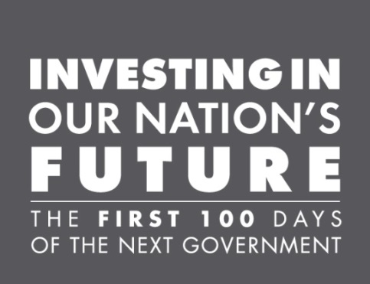our party conference engagement.

We hosted debates and fringes at each of the three main party conferences, with LGA councillors speaking at 141 events. This meant that members contributed to 12 per cent of all fringes held across the three main party conferences

We have also worked to support councils on a wide range of issues including:

**Council finances**

* Following consultation with councils**, reached agreement with trade unions** on a 2.2 per cent pay deal, which provides financial certainty on pay bill costs until April 2016
* the government has **committed to review the Bellwin Scheme** and amended it to reduce the threshold following the severe weather of last winter
* **ensuring that the Deferred Payments Agreements scheme runs on a cost-neutral basis**, councils will be able to charge interest on the deferred fees to cover the cost of lending.

**Crime, community safety and licensing**

* Secured councils’ **continued access to communications data** to track down organised gangs and rogue traders preying on the vulnerable
* **put licensing reform on the national agenda**, including the absurdity of issuing licences to business’ who owe councils thousands of pounds in unpaid business rates
* securing **council representation on the Home Office National Group on Sexual Violence**
* Government announced its intention to create (and subsequently consult on) a **separate planning use class for betting and payday loans shops,** following our lobbying on concerns about betting shop clustering
* DWP have agreed a **broader definition of fraud** that will be investigated by Single Fraud Investigation Service (SFIS) significantly simplifying arrangements for councils

**Health and social care**

* Giving councils **discretion to refuse a request for a deferred payment agreement** under the Care Act where they are unable to secure a first legal charge on a person’s property

* in response to concerns about the affordability of the Care Act in 2015/16 the Department of Health has **committed to monitoring the costs of the Act next year**
* ensuring **councils are recognised as primary partners** alongside the DWP in the delivery of Local Support Services for Universal Credit

**Children and young people**

* Working with the Adoption Leadership Board, we helped increase the number of **children adopted by 15 per cent and the number of approved adopters by 34 per cent** over the past year
* influencing government proposals to allow councils to **delegate children's social care functions to third party providers, with the introduction of a specific restriction on profit-making companies** delivering these services
* we won the argument to **restrict the number of transfers to the new Education Health and Care (EHC) plans**, saving councils significant additional work

**Infrastructure**

* Secured changes to the proposed **delivery of Sustainable Drainage Systems (SuDS)** which means that no council is required to adopt and maintain a SuDS.
* secured a **requirement in the draft licence of the new strategic highways company (that will replace the Highways Agency) to consult with councils** on their investment plans and operation of their network.

**The national voice of local government – Councils in the media**

As the national voice of local government we are uniquely placed to campaign on your behalf. We press for change in those areas that matter most to you and to your communities. As well as our parliamentary activity, we do this through the media. We provide the national press office for local government – a 24/7, 365 days a year service committed to protecting and promoting the interests of councils. We promote the work you are doing in the national, regional and specialist press – and stand up for councils by rebutting negative stories.

In 2014, we achieved 1504 episodes of media coverage times in national newspapers – an increase of almost 50 per cent on 2013. Our team of spokespeople from councils up and down the country took to the airwaves 475 times across all broadcast channels and was interviewed 151 times on UK national TV and radio stations.

We provide a free news headlines service to all member councils, saving you thousands of pounds and our weekly email to all council communications teams – *Commsnet* – generates hundreds of case studies which use to get media coverage for councils.

**Practical support for councils**

Member councils also receive:

* a regionally-based Principal Adviser, who acts as your first point of contact with the LGA, advising on the support and services available. Your Principal Adviser will be in regular contact and undertakes numerous visits to councils over the course of the year. <<(MERGE) Local Authority Principal Adviser is and can be contacted on (MERGE) >>
* support from specialist advisers across a range of policy areas
* on-the-day briefings covering all major government announcements – including the Queen’s Speech, the Budget and major legislation which may affect your council
* on certain complex issues, access to free legal advice and opinions commissioned by the LGA. Legal opinions can cost individual councils tens of thousands of pounds
* free access to advice on pay, pensions and employment.
* discounts on Microsoft and Adobe software licences through participating resellers

**LGA conferences and events**

Councillors and officers from member councils have access to more than 100 free or discounted events, from small seminars to large residential conferences. 87 per cent of our events this year have been free to attend for our members and half were held in the regions.

Member authorities receive a 42 per cent discount on one-day events and a 23 per cent discount on residential events, including our annual conference – the flagship event for local government.

We also arrange roundtables, briefings, seminars and receptions at the main party conferences, and an annual conference for Independent and smaller party councillors.

<<(MERGE) x members and (MERGE) XX officers from local authority attended events in 2014

**Improvement, innovation and development**

The current financial challenges mean that finding new and innovative ways to improve effectiveness, increase efficiency and reduce costs is more important than ever. The LGA facilitates sharing of ideas and best practice, helping councils build capacity to support one another. In the past 12 months, more than 140 councils have received a peer challenge and we have supported a further 50 to achieve twice their forecast efficiency savings in adult social care. Member councils have access to:

* one free **corporate peer challenge** every three years
* **themed peer challenges** by arrangement, including, finance, communications, adults and children’s safeguarding, health and wellbeing, planning, and fire. <<MERGE Local Authority received XXXX corporate peer challenge and x safeguarding review in year>>
* a revised and extended **financial support** offer. In recognition of the increasing importance of financial issues and councils’ comments we have extended peer support on finance and added to the financial diagnostic tools made available to all councils, such as the spidergram
* **bespoke peer support** such as up to five days ‘change of control’ support for new leaders/cabinet members and tailored peer mentoring support for individual councillors from experienced councillors with relevant expertise
* **productivity support** to help councils increase financial sustainability under four broad themes – Procurement & Commissioning, Commercialisation & Capital Assets, Children, Adults & Families and Future Ways of Working. Our productivity experts have supported22 councils to realise efficiency savings and 38 councils have received bespoke support to deliver economic growth (MERGE – PRODUCTIVITY or ECONOMIC GROWTH)
* **LG Inform** – a free on-line benchmarking service that allows anyone in a council or fire and rescue service to compare their performance with other similar authorities and presents the information in report form. We also provide free ward reports from LG Inform Plus, our premium data and information management service. The LGA provided free advanced LG Inform/LG Inform Plus training for (MERGE) local authority staff this year.
* **Communications support** ­– Increasingly, member authorities are requesting communications support as part of our sector led improvement offer – ranging from crisis communications assistance to media relations advice. More than 30 councils received support from our communications team during 2014/15. We are uniquely placed to offer support, advice, training and access to best practice – and are now developing our communications offer as an integral part of the benefits package you receive from LGA membership.

**Leadership programmes**

We offer a range of free or subsidised programmes, courses and materials to support councillors, groups of councillors and officers in their various leadership roles.

**Leading Edge**

A unique opportunity for leaders to work with chief executives on key leadership challenges.

<<(MERGE) X Cllrs from authority attended Leading Edge programmes in 2014/15>>

**Leadership Academy**

Three two-day residential modules delivered in a cross-party setting for councillors in leadership positions to learn more about the latest in political leadership. <<(MERGE) X Cllrs from authority attended Leadership Academy in 2014/15>>

**Leadership Essentials**

Themed programmes and workshops for councillors in leadership positions to share experiences with others who face similar challenges. <<(MERGE) X Cllrs from authority attended Leadership Essentials programmes in 2014/15>>

**Next Generation**

A prestigious leadership development programme for ambitious councillors delivered in a party political group setting – free to nominated members <<(MERGE) X Cllrs from authority attended **Next Generation** in 2014/15>>

**Change of Control**

5 days free consultancy support to new political administrations, to enable them to ‘hit the ground running’ following a change of control

**Focus On Leadership**

Development programmes for councillors with potential or aspirations to move into leadership positions

<<(MERGE) X Cllrs from authority attended Focus On Leadership programmes in 2014/15>>

**Community Leadership**

Free support for councillors in their community leadership role including in-house training programmes, workbooks and E-Learning modules.

**The Councillors’ Guide**

A comprehensive guide to support new councillors to be as effective as possible in their new role

**National Graduate Development Programme**

Recruits high calibre graduates into local government. <<(MERGE) LA has x trainee on the NGDP>>

**Developing the Future Workforce**

Support to councils on strategic workforce issues arising from public service transformation

**Local Government Challenge**

Aspiring top managers compete for the £10,000 Bruce-Lockhart scholarship in a six month long competition hosted by councils across the country. <<(MERGE) LA has x contestant in the LG Challenge>>

**Political support for elected members**

There are four political groups at the LGA who work with members across the country – Conservative, Labour, Liberal Democrat and Independent. The political groups:

* work closely with, and where appropriate, challenge government, shadow teams and party administrations
* help shape our campaigns, policy, media and public affairs work
* offer advice, guidance and support to individual councillors and to political groups in councils
* run briefings and events for elected members around the country, often with senior government figures
* attend and run sessions for councillors at the Autumn and Spring party conferences
* maintain a watching brief over council performance and coordinate political involvement where necessary
* coordinate the LGA’s peer support programme through the political lead peers
* coordinate appointments to the LGA’s boards, panels, commissions and to a range of outside bodies

|  |  |
| --- | --- |
|  | conservativegroup.lga.gov.uk  Tel: 020 7664 3264 |
|  |  |
|  | labourgroup.lga.gov.uk  Tel: 020 7664 3263 |
|  |  |
|  | libdemgroup.lga.gov.uk  Tel: 020 7664 3293 |
|  |  |
|  | independentgroup.lga.gov.uk  Tel: 020 7664 3224 |

**Access to free facilities**

Local Government House, in the heart of Westminster, is a resource for all of our members to use. Fully accessible, with a range of bookable meeting rooms and a conference centre on the ground floor, member councils have:

* free use of the Open Council coffee lounge and Members’ Terrace Lounge for small, informal meetings. The Members’ Terrace Lounge has direct access to the roof terrace
* access to a range of bookable meeting rooms – from quiet rooms for 2-3 people to the Westminster Suite which can seat up to 100 people. Any member council or group of member councils can book up to five rooms a year, free-of-charge and subject to availability

**Getting involved**

The LGA General Assembly acts as the ‘Parliament for local government’. It meets annually every summer before the Annual Conference to elect office holders, hear from the Chair of the Association and to debate matters of importance. Every member council is allocated a number of voting places. You can also get involved in the work of the LGA through:

* appointment to any of our boards which cover every area of local government as well as our own internal operation
* coming along to one of our Councillor Forum meetings to hear speakers and discuss current issues for local government
* joining a task and finish or advisory group tackling a particular topic
* membership of one of our many special interest groups - such as the County Councils’ Network (CCN), District Councils’ Network (DCN), the Special Interest Group of Municipal Authorities (SIGOMA), Rural Services Network and the Strategic Aviation SIG (SASIG). They cover a wide range of topics – from coastal authorities and small rural authorities to councils with ALMOs and with shared chief executives.

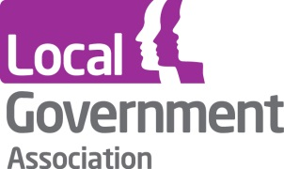

**Contact the Local Government Association**

Telephone: 020 7664 3000

Email: [info@lga.gov.uk](mailto:info@lga.gov.uk)

Website: [www.local.gov.uk](http://www.local.gov.uk)

© Local Government Association, January 2015

For a copy in Braille, larger print or audio, please contact us on 020 7664 3000.

We consider all requests on an individual basis.